Industrial, Manufacturing, & Systems Engineering
College of Engineering

Systems Engineering Project Practicum
Summary
Project Title: | Body Drying and Inspection Apparatus
Team members: | 1. Sergio Flores  2. Valeria Chavira  3. Flor Manzanares  4. Alberto Chavez  5. Jesus Rivas
Instructor: | Dr. Oscar Mondragon
Semester, year: | Spring 2018
Type of project: | Individual project at students work ( )  Team project assigned by instructor ( X )  Project proposed by team ( )

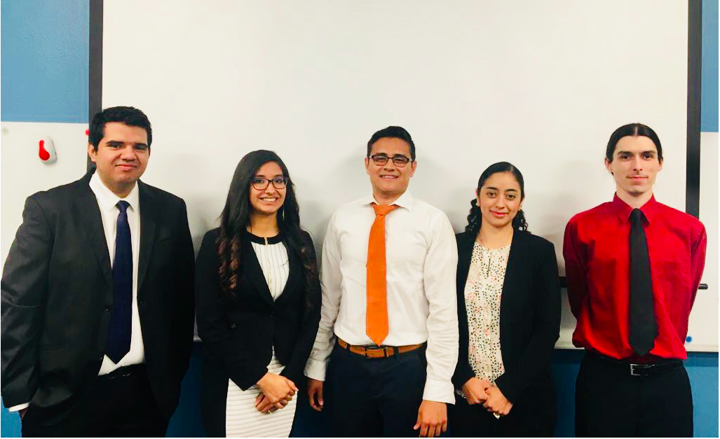

Team members (from left to right):

Sergio Flores, Valeria Chavira, Jesus Rivas, Flor Manzanares, and Alberto Chavez

INTRODUCTION
Th The System Engineering Project Practicum provides the opportunity to apply System Engineering concepts in developing a real system and create documents that formally describe the system. Students review documents and validate them with clients and customers through formal presentations. Teams are self-managed and assign roles to control planning, quality, requirements, design, and implementation.

System Overview
There are many people suffering from different health conditions, mainly diabetes. Diabetes is a condition that causes several complications and must be monitored consistently. The patient’s glucose level, body weight and the condition of limbs and areas of the body that may be affected by reduced blood flow must be monitored. All this data must be evaluated by health professionals to know the current health status of the patient and determine the proper treatment for their actual condition.Remote health monitoring will reduce healthcare office visits, loss of work (directly or indirectly), hospitalizations, non-healing infections/wounds, amputations and death.

There is a need to develop a system that facilitates body drying and inspection for diabetic wounds, weight, and vital signs (pulse/pulse oximetry, glucose levels, blood pressure), and imaging sent via a network. The problem that is being addressed is the monitoring, prevention, and the dryness of skin preventing infections or future wounds.

The project is a system to monitor and control aspects of diabetes, which are: the wounds generated by low blood flow in some parts of the body (the peripheral vascular disease), glucose measurement, weight measurement, blood pressure measurement, pulse/pulse oximetry measurement, imaging, and preventing infections in the wounds by blowing filtered air to the wounds to dry them; with a potential for general use. The system can work as a personal device, or it can be implemented in specified centers where the patients or people treating the patients can make use of it. The problem that is being addressed is the
monitoring, prevention,and the dryness of the skin for preventing infections or future wounds.

Currently, a body drying and personal inspection apparatus (BDIA) is provided for air-drying and for providing the user with several inspection and data input devices. The apparatus comprises a base platform and an upright member with one or more handles to support the user. A dryer assembly forces air through the base platform and through an elongated dryer tube handled by the user. Further provided is an inspection camera coupled to the dryer tube and a foot camera within the base platform, both used to capture images of the user’s body while on the platform. A display and processing system is also provided that allows images to be processed and displayed, for input to be received via a user input device, and for data to be transmitted to a health care provider over a network. The base platform also provides weight-measuring capabilities for measuring the weight of the user thereon. The main purpose of this project is to identify areas of opportunity in order to improve the current system.

The success of this project is very important as it will be a life changer for many people that suffer from certain conditions, mainly diabetes. Delivering a system that will help diabetics keep different areas of the body dry, monitor vitals signs, and electronically transmit data to the health provider, by using quality products, incorporating new technology, and making it user-friendly and accessible in order to facilitate self-inspection and self-monitoring.
The focus of this project is to address the current prototype issues and work on the areas of opportunities provided by the customer, and areas of opportunities identified by our team through the use of techniques based on research of similar devices.

System Description

The system main functionalities are to daily monitor diabetic wounds, weight, and vital signs (i.e blood pressure, glucose, and pulse and pulse oximetry). The system has the functionality to dry the body (feet, perianal, under folds, axilla) as needed. Also, the system has the functionality to capture images of affected body parts. The system also has the functionality to send images and vital signs to the healthcare provider for analysis.

The Context Diagram Level 0 shows the system as a whole. It shows the external entities and the
information being sent from the system to the external entities and from these entities to the system.
The Context Diagram Level 1 shows the decomposition of the system into its main services/components
and shows the information being sent from each of these services/components to the external entities
and data received from these external entities.

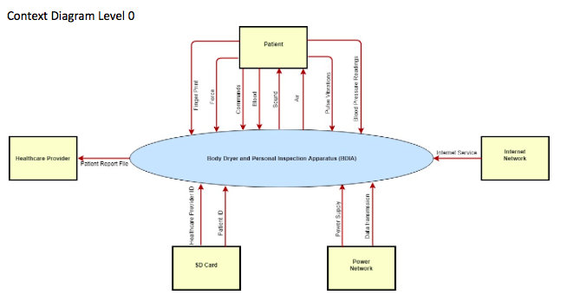

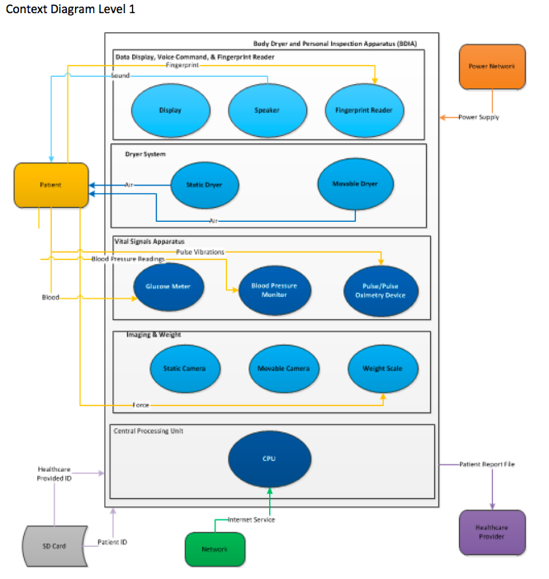

Use Case Diagrams
A use case diagram is the depiction of the interaction between the system’s main actors and the services it has.

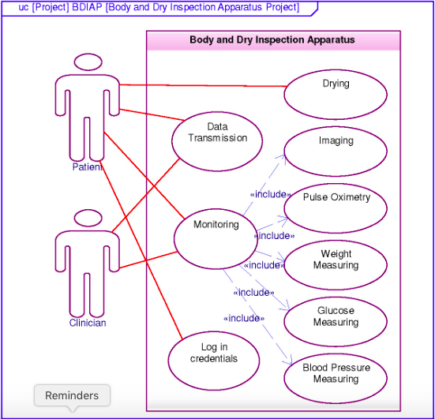

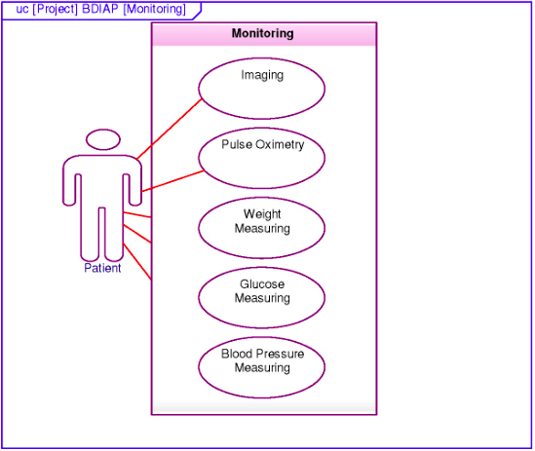

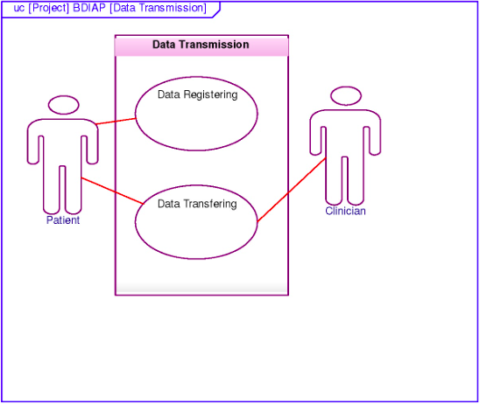

List of Actors
The list of actors that play an active role in the use of the the BDIA system are as follow:
- Patient - the patient will be using the system to get weight measurement, glucose level measurement, blood pressure measurement, dry affected areas, and capture images of the affected areas to be electronically transmitted to the health provider for further analysis.
- Healthcare providers:
  - Clinician(s) [Primary Physician, Endocrinologist, Nephrologist, Nurse, and Orthopedic surgeon] - the clinician will be receiving via network, the patient’s medical file for a specific date that will contain medical information such as glucose level, weight, blood pressure, and images of the area(s) affected for analysis and provide the appropriate treatment.
  - Nurse Practitioner - the nurse will be receiving via network the patient’s medical file for a specific date that will contain medical information, such as glucose level, weight, and images of the area(s) affected for review

List of Services
The list of services for the BDIA System are as follow:
Login Credentials
- Finger identification: The system uses a fingerprint identification device to validate the user and provide access to the system.
Drying
- The system comprises a static dryer and movable dryer. In particular, a blower motor and heater assembly forces air through the base platform and towards the standing user. In conjunction with the base platform, an elongated blower tube is provided so the user can control to direct forced air to various parts of his or her body. The dual blower outlets provide a means to dry a user after a shower or bath.
Monitoring:
- Imaging: A pair of cameras is provided to capture images of the patient's body. An inspection camera coupled to the blower tube and a foot camera within the base platform, both used to capture images of the patient’s body while on the platform.
- Weight-measuring: The system provides weight-measuring capabilities for measuring the weight of the patient.
- Glucose-measuring: The system provides glucose-measuring capabilities for measuring the glucose levels in the blood stream.
- Blood pressure measuring: The system measures the blood pressure of the patient, then display the value in the monitor, this value will be recorded in the internal hard drive and then sent to the clinician.
- Pulse and Pulse oximetry measuring: The system measures the pulse and the oxygen saturation of the patient’s blood, then displays the value in the monitor, this value will be sent to the clinician.
Data Transmission:
- Data Registering: The system allows to register all information needed to create a patient profile such as name of the patient, data and time, specification of affected area as well as health care provider information.
- Data Transferring: The system transfers all the data to the healthcare provider over a network to be analyzed.

Activity Diagrams
Activity diagrams are graphical representations of scenarios that depict decision, iteration, concurrency, swim lanes, and synchronization. Activity diagrams enhance flow diagrams by using swim lines columns that shows the activities for each actor/role.
The following diagrams are the activity diagrams for the BDIA two main services.

Camera Service

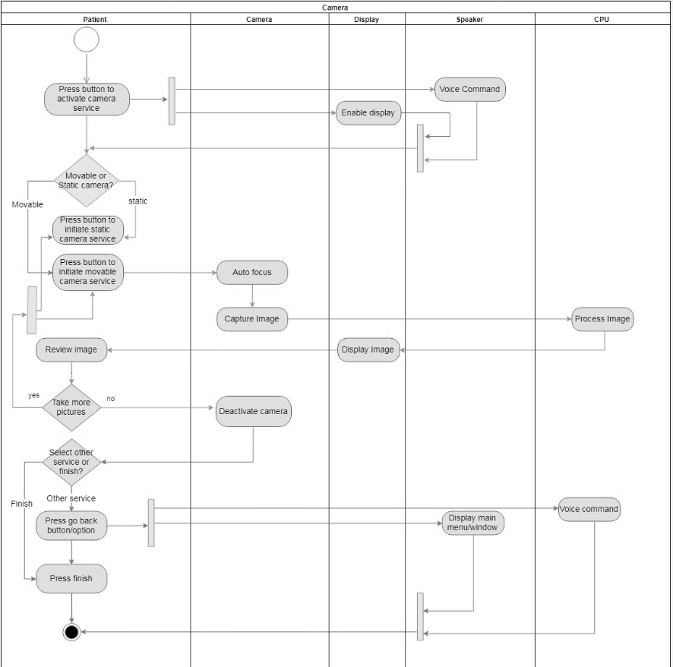

Drying Service

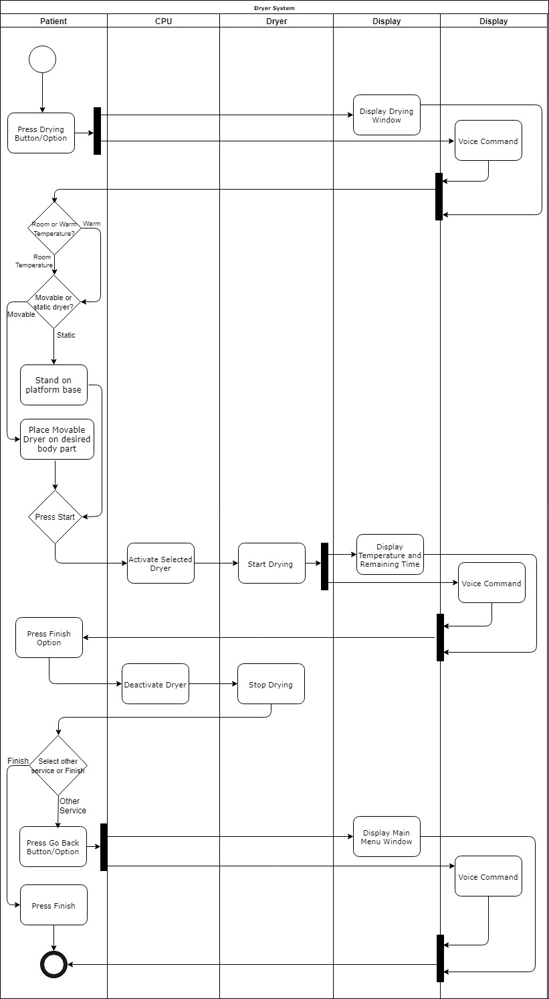

Block Definition Diagram & Internal Block Diagram
Block Definition Diagram (BDD) defines the scope of the system by displaying the System Of Interest (SOI) in a block and the system components in blocks linked to the SOI. The BDD also includes the input and outputs for both the SOI and its components. BDD depicts the composition and classification of the structural elements.

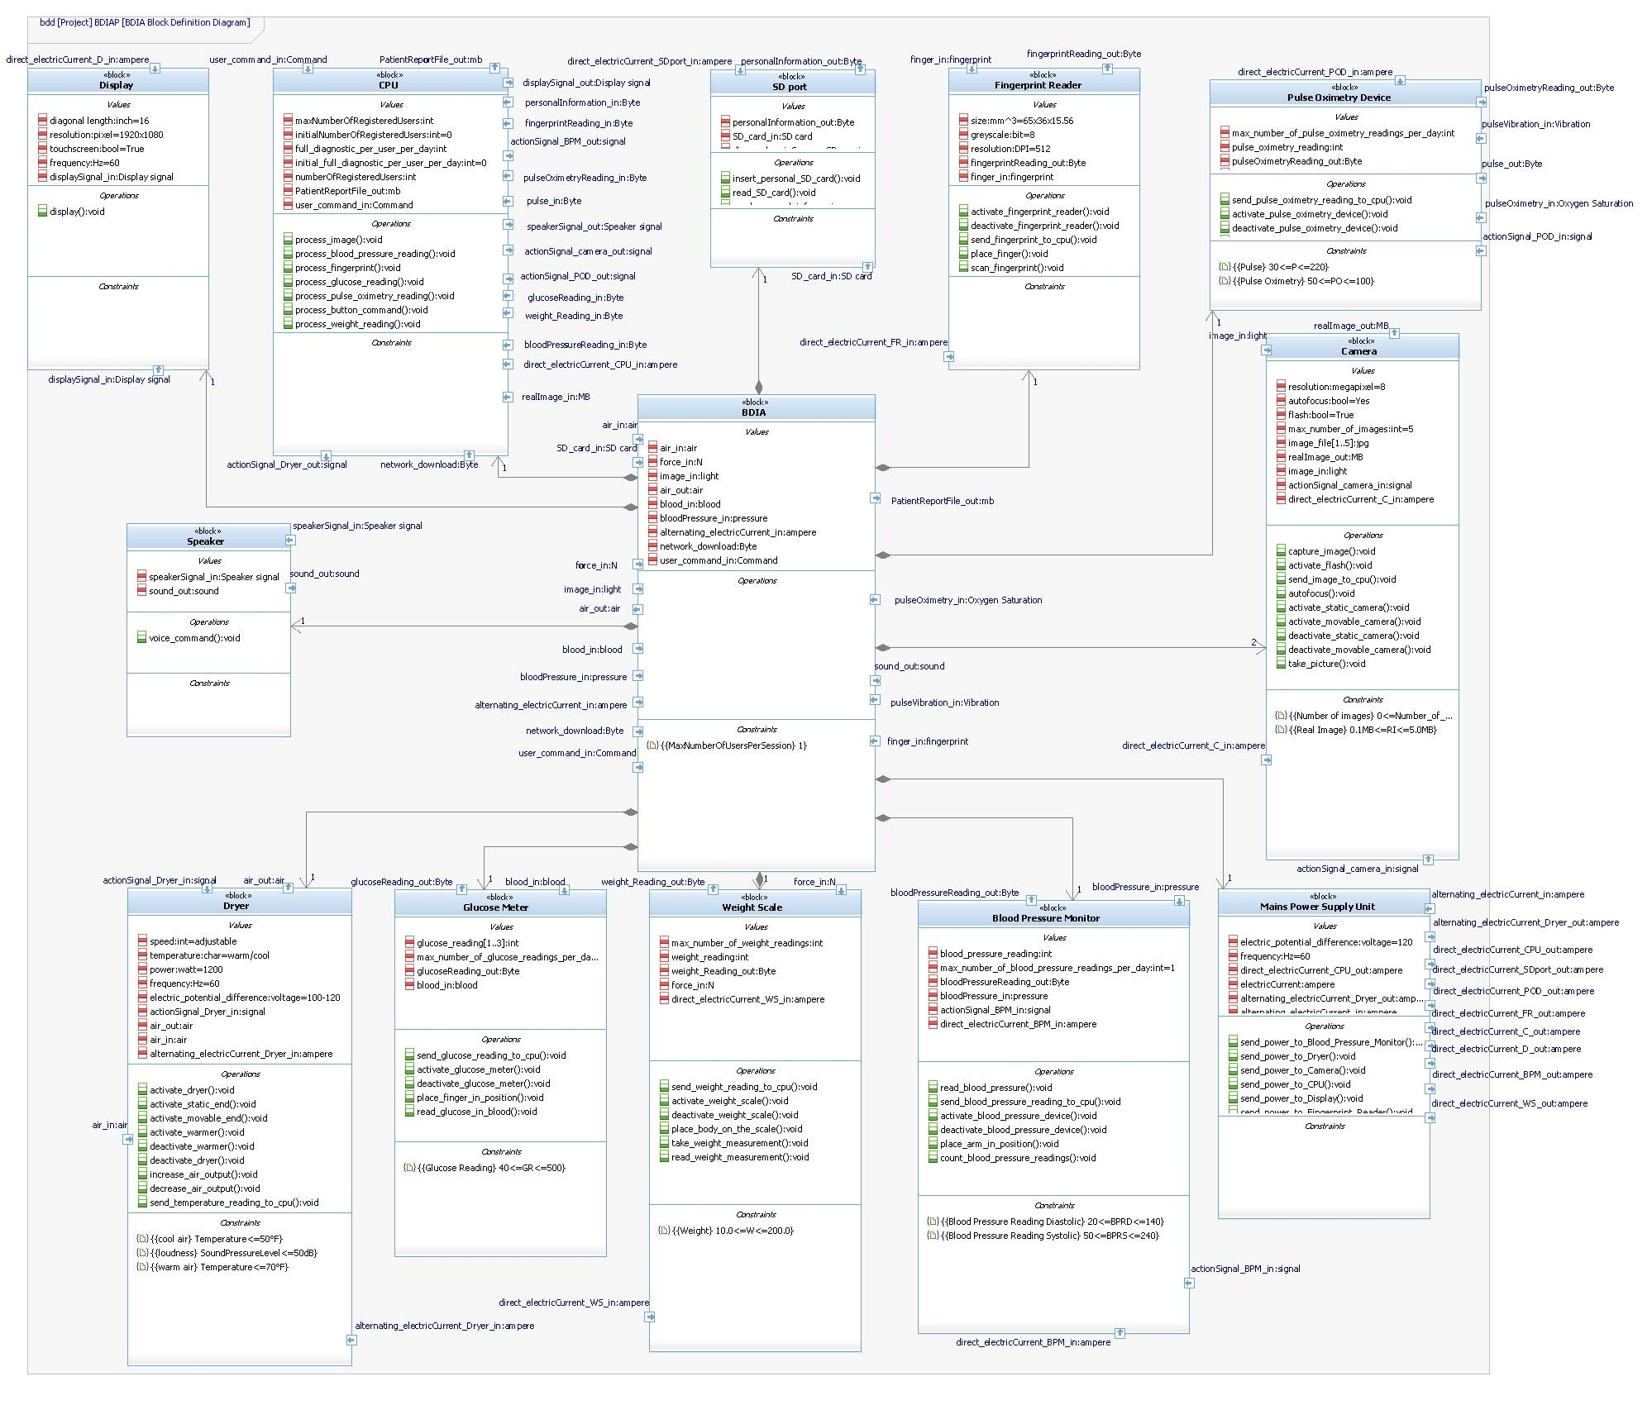
Internal Block Diagram (IBD) models the interaction among components and the transformation of system inputs into outputs. IBD is a complement of the BDD and the name and number of components, inputs and outputs should be consistent between both diagrams. IBD depicts the flow of matter between system components and the interface definition by using ports.
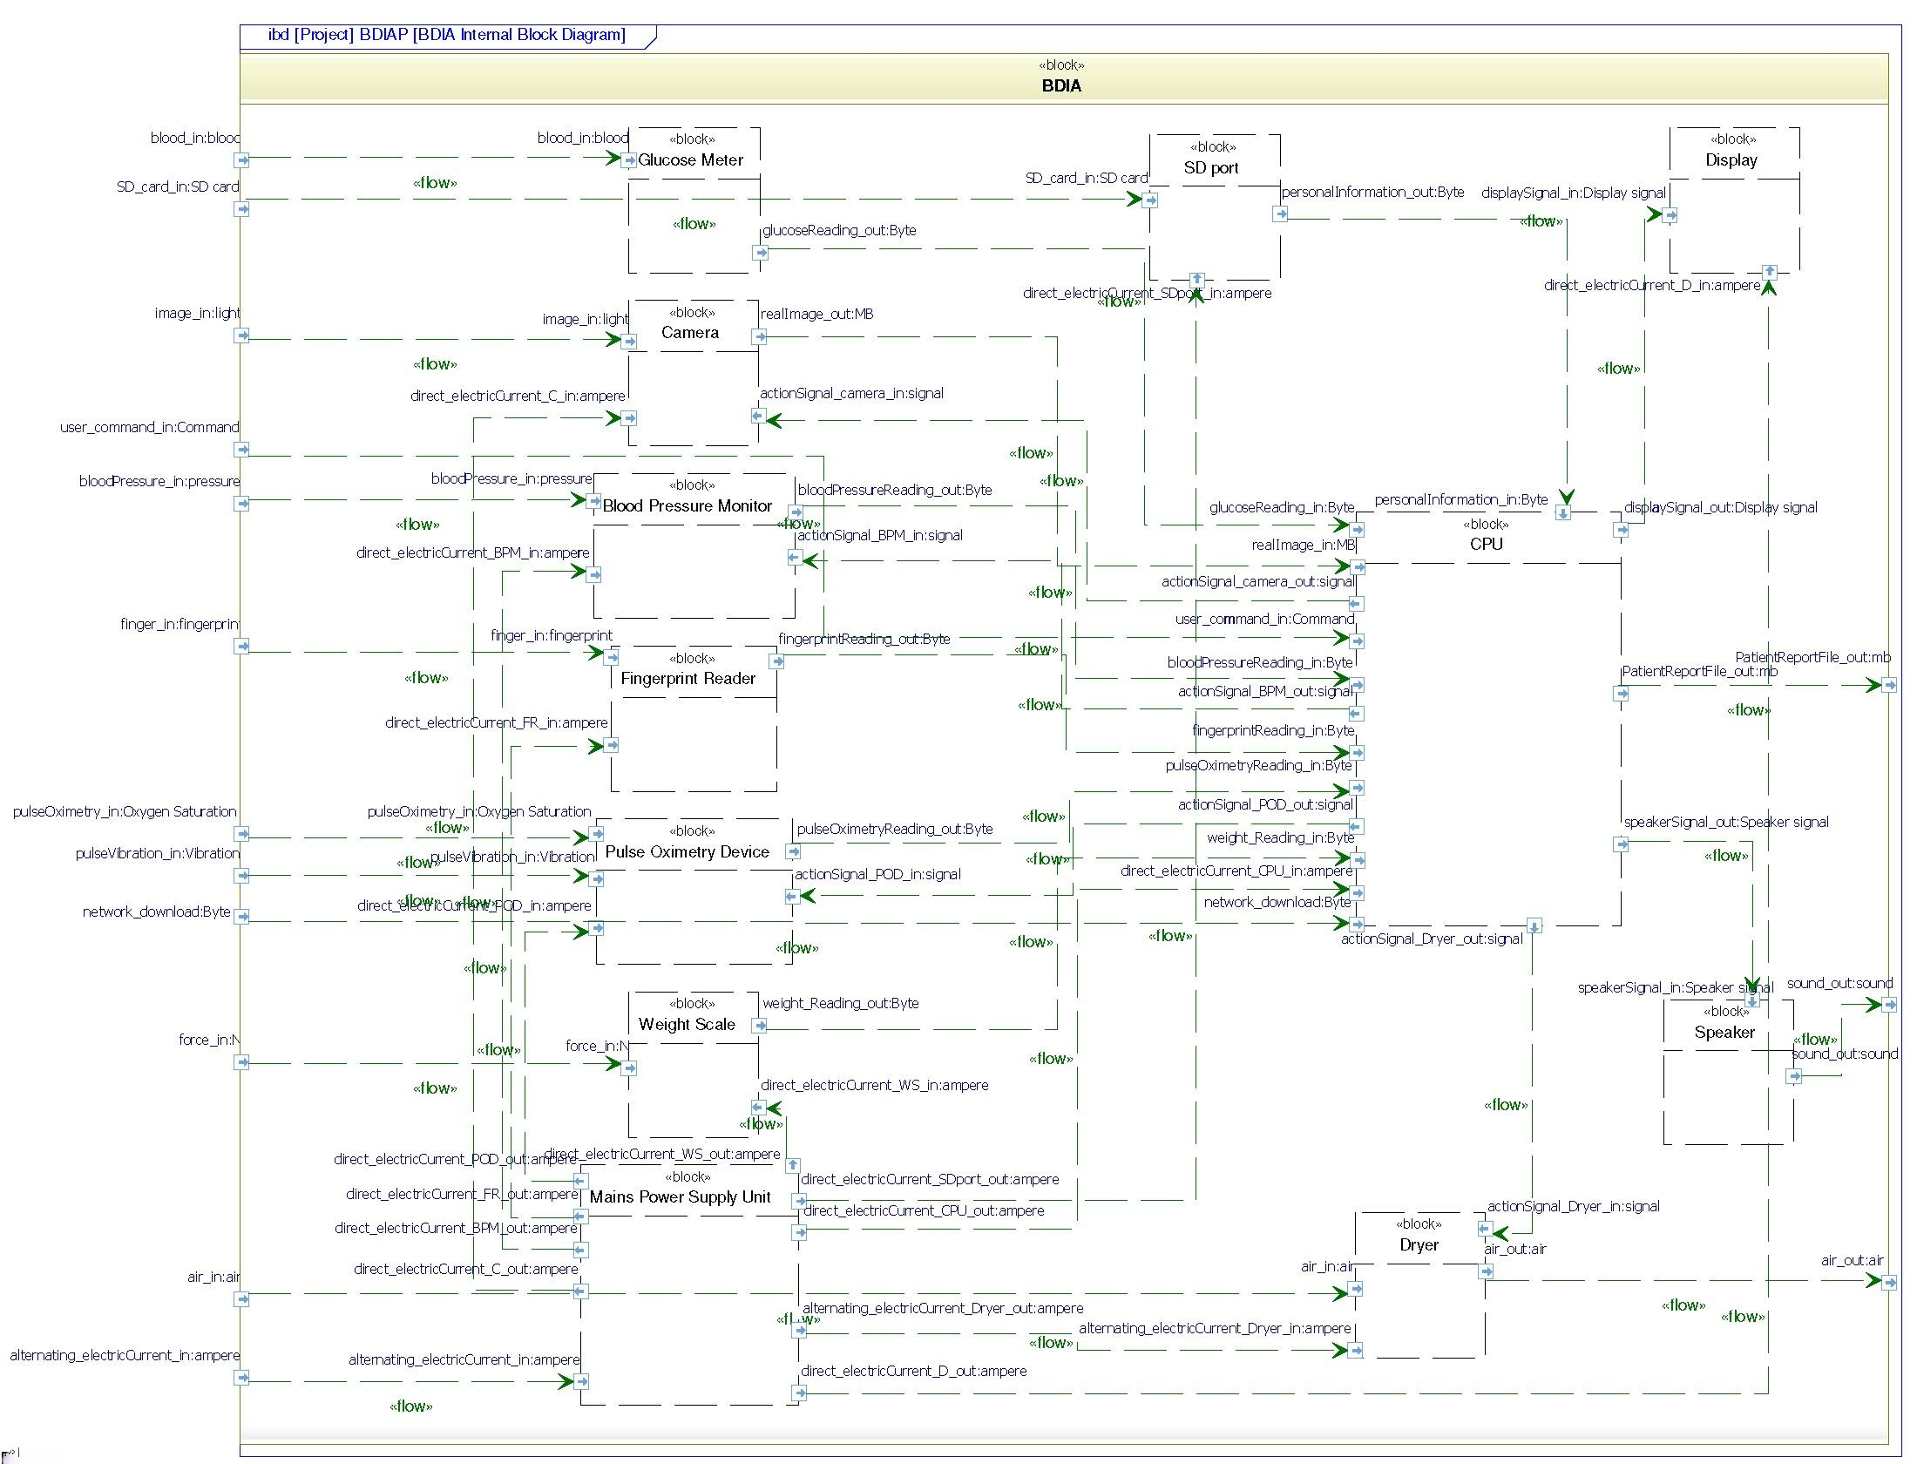

PROJECT OUTCOMES
The impact of the Body Drying and personal Inspection Apparatus for OTEN Medical will improve the lives of people with diabetes in America and around the globe. The work that the team did during this semester will help OTEN Medical to have an engineering perspective for the development of the BDIA system. The team gather OTEN Medical requirements and translated them into Systems Requirements. The team created a prototype of how the screens and options/information would be displayed on the monitor. The team also created a system design that included different diagrams that could help visualize how the system will be integrated and operate from a more technical perspective. Furthermore, the team created test cases that will serve as a guidance for the next prototype version. Finally, the team created a quality dashboard that includes the hours spent working in each phase, the hours spent working in each review, as well as the defects injected and the defects removed. This information was helpful to assess the effectiveness of our review process and to evaluate the quality of our project as a whole.

The reviews are a verification methodology that are essential in the completion and success of every system. It is important to have reviews at the end of each lifecycle to make sure that it remains within the scope and that all requirements are being met.

Quality Metrics
The Quality Dashboard provides an executive summary of the project quality.

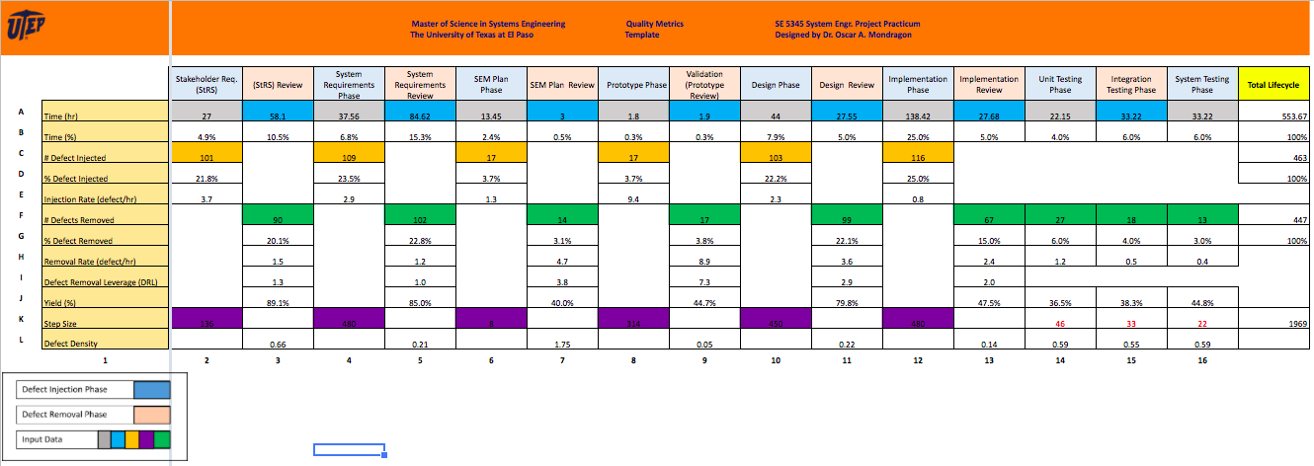

Some of the skills that our team had to developed to work successfully on the team are: communication, flexibility, and responsibility. The communication was key in the success of our project as most of our meetings and discussions were by group instant messaging. Flexibility was also important. Some of our team members had full time jobs or other activities that made it difficult to meet face-to-face but needed to be flexible to attend those meetings. Finally, responsibility was very important in order to complete all the tasks on the due date.
In order to be successful as a team in this project, our team committed to be honest with the rest of the team members, to actively participate in team meetings and discussions, and to be responsible and complete the tasks assigned on the agreed due date.

MASTERS OF SCIENCE IN SYSTEM ENGINEERING PROGRAM ASSESSMENT
During the Systems Engineering masters program, our team developed and improved some soft
skills,learned methodologies and techniques that can be applied in our professional life, and also had the
opportunity to participate in student organizations and had job offers.

Some of the soft skills that out team developed/improved during the program are:
- Team work
- Leadership
- Communication
- Time management
- Ability to work under pressure

Some of the methodologies and techniques that the team learned in the program are:
- CMMI for Development
- Personal Software Process
- Team Software Process
- Black Box/White Box Testing
- AGILE
- Other Methodologies (“Vee”, Waterfall, Spiral, etc.)

During the master’s program two of our team members got job offers at Cummins and Lockheed Martin. Also some of our team members traveled to San Francisco, CA with the INCOSE student chapter to a plant tour of Tesla and Google.

Some the skills that the team learned and will use in our professional life are project management, teamwork, customer interface, leadership, and communication. The team also learned how to use some software programs during the program such as Rhapsody, SIMIO, and Enterprise Architect.

